**CRITERION B: DESIGN**

Wireframes:

Log in: Current registration page: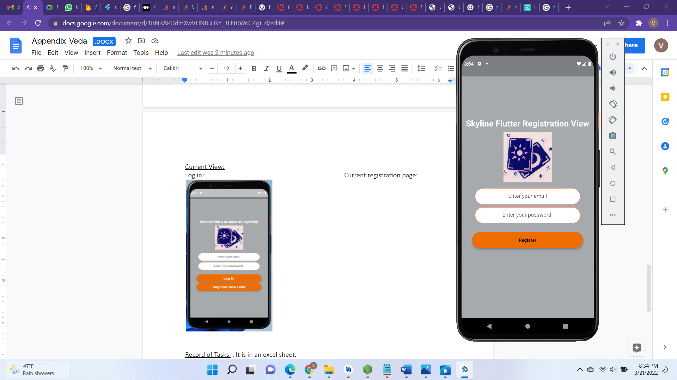

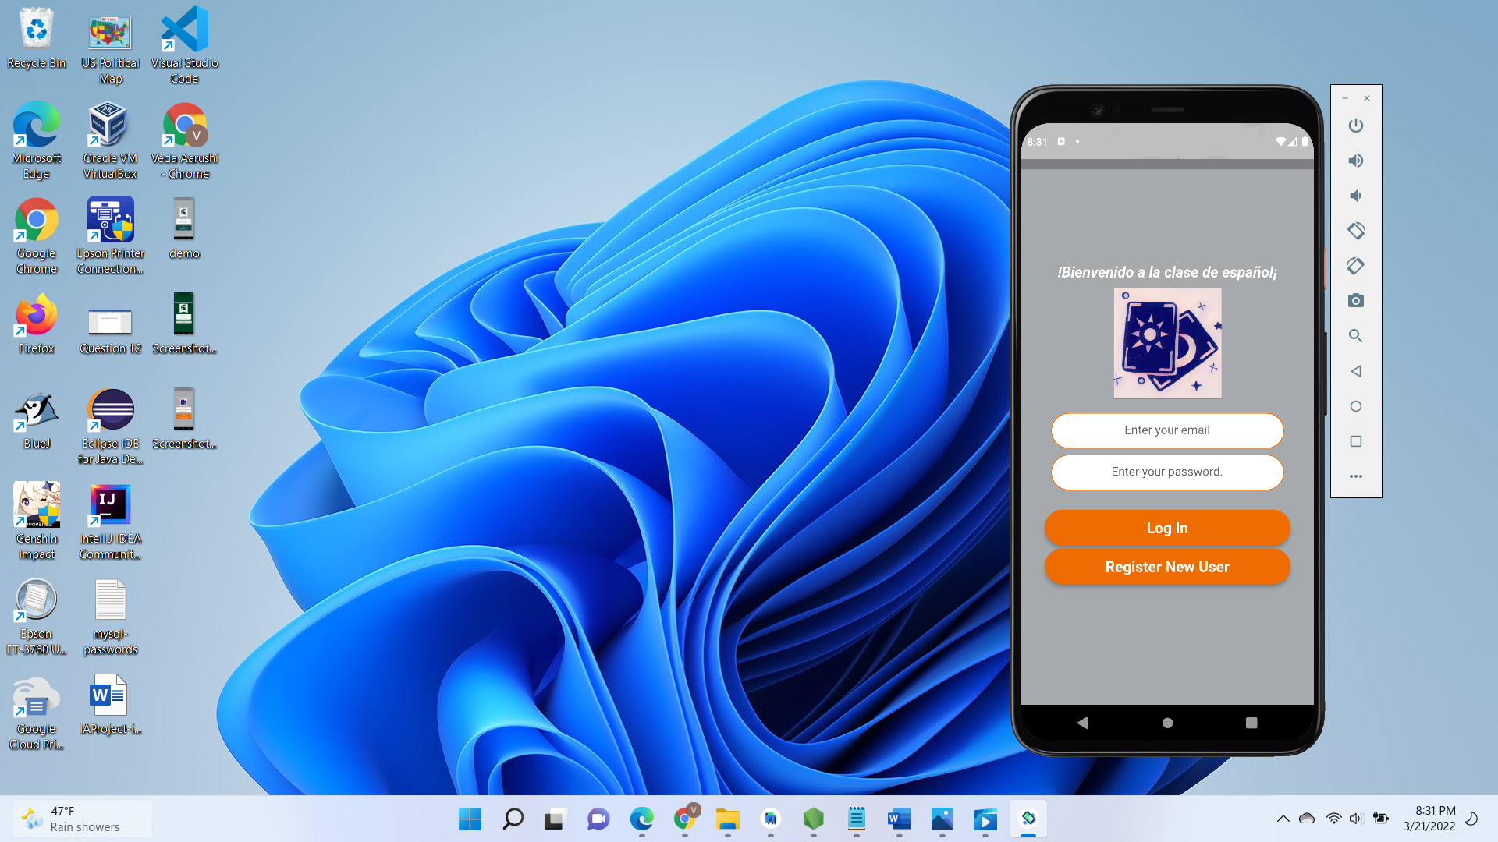

Game menu: Memory game menu: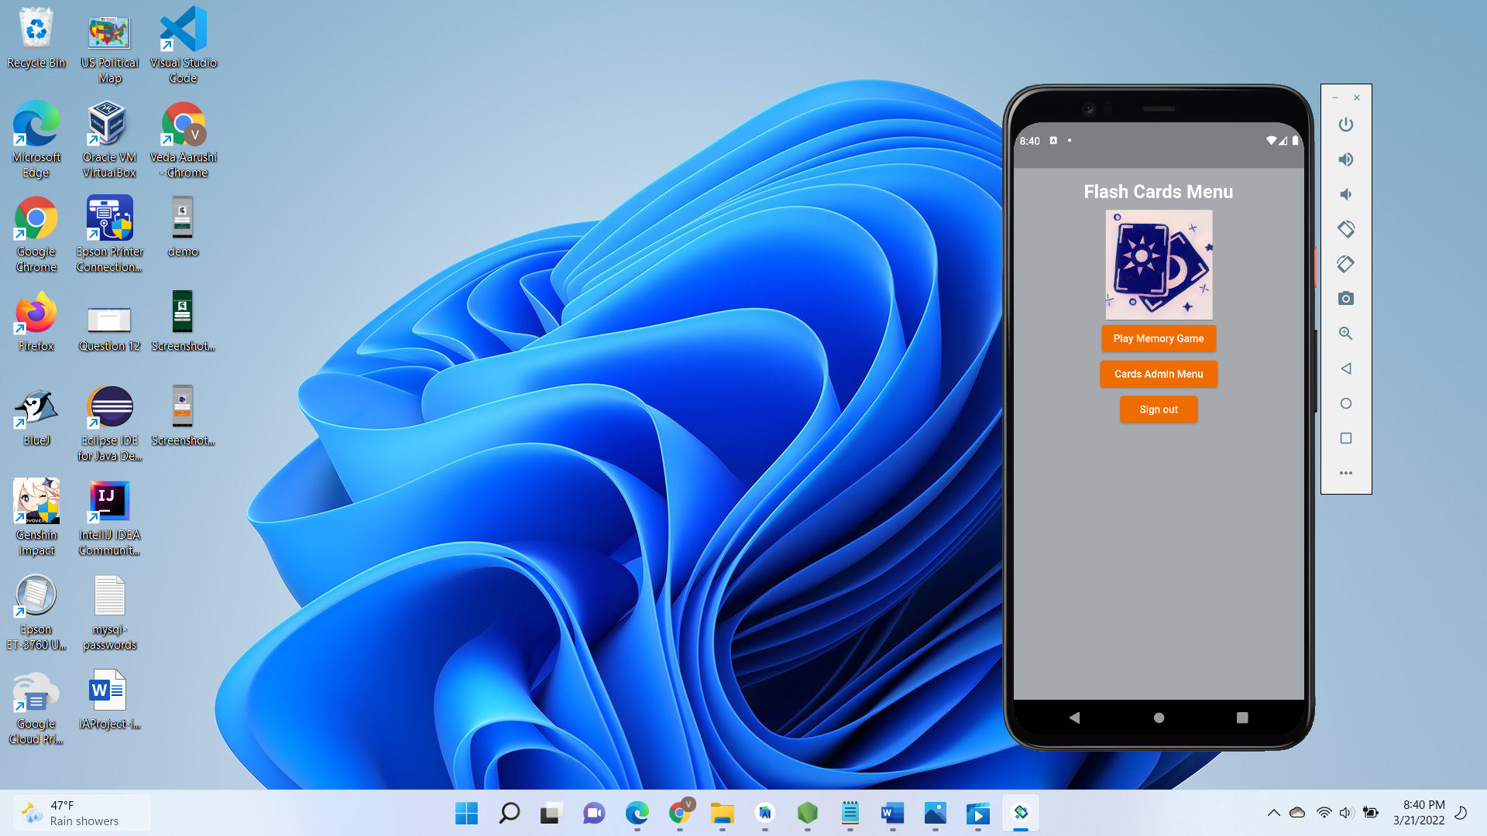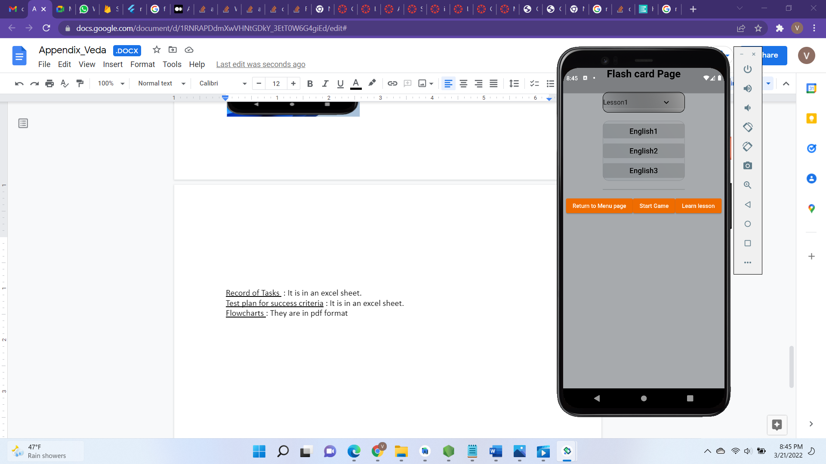

Memory game view: Card Admin Page:

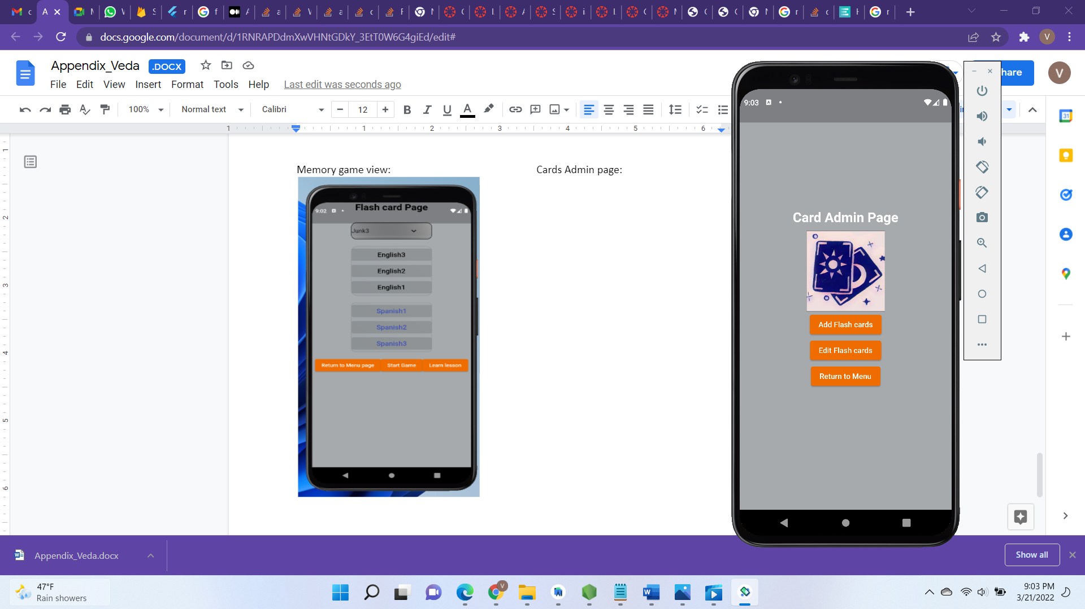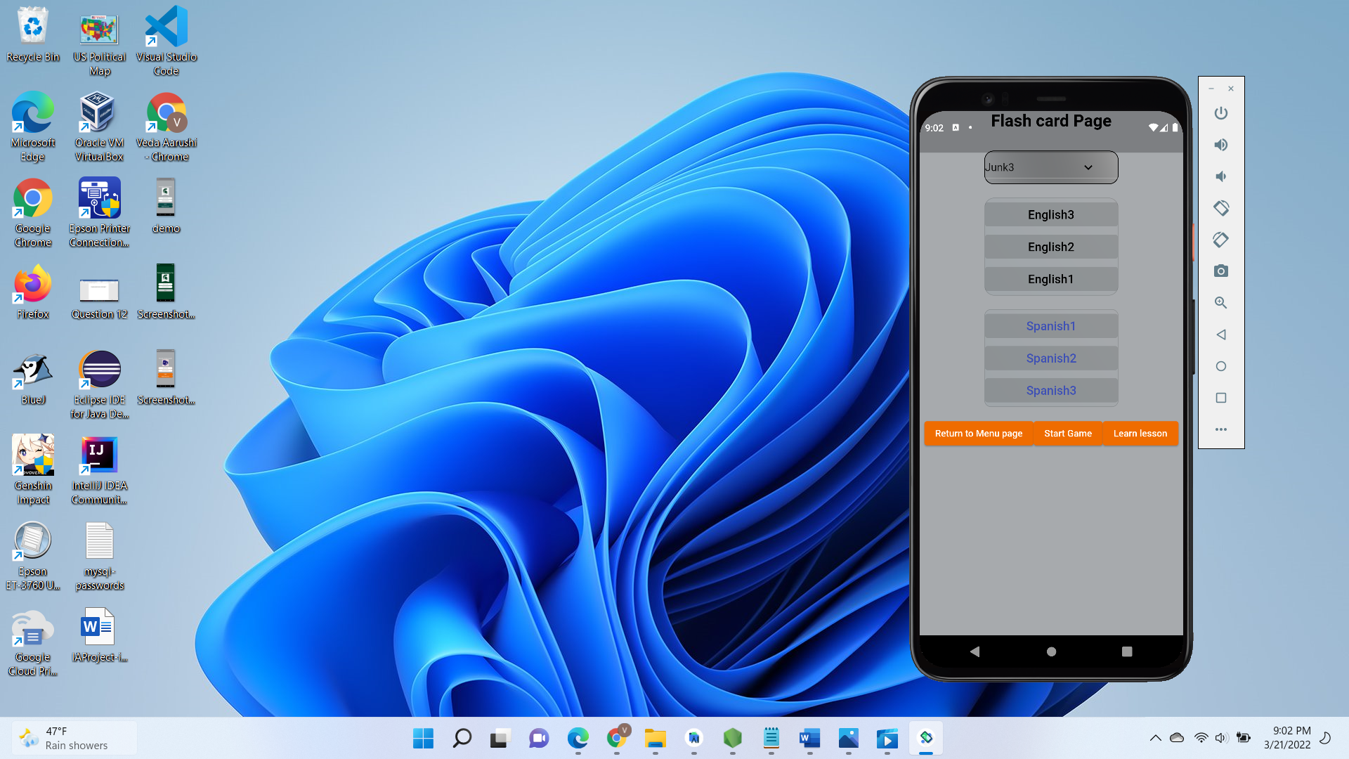

Add Flashcard view: Edit flashcard view: 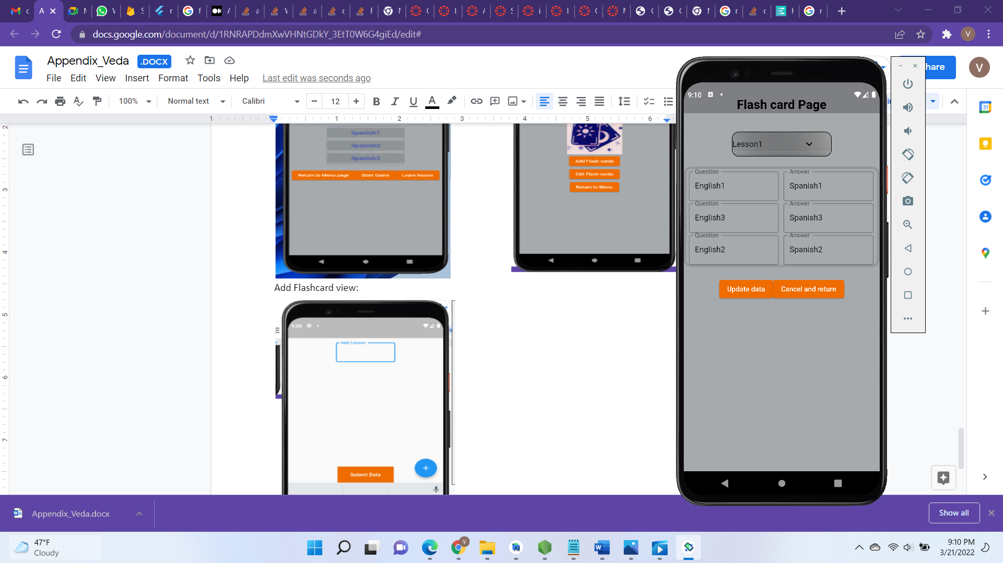

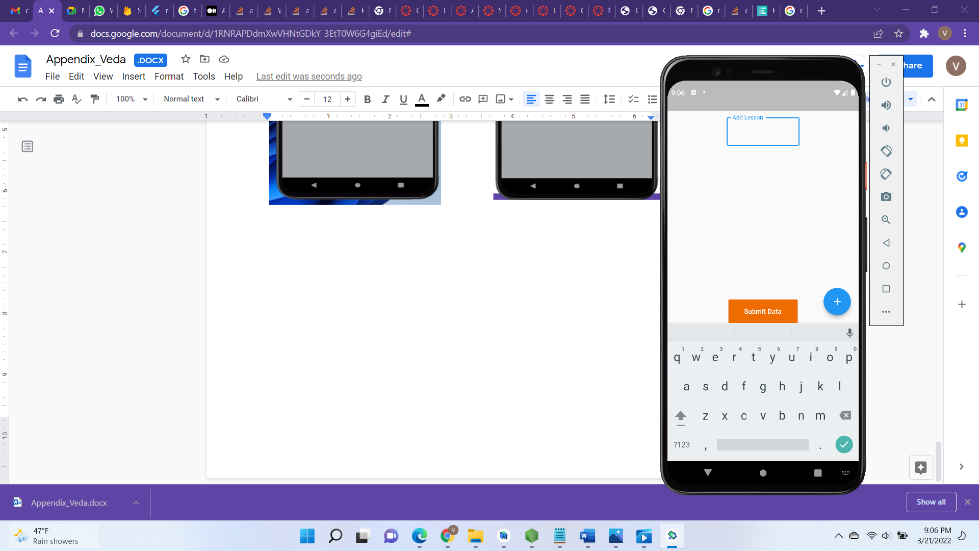

LINK to use case diagram and class diagram:

https://drive.google.com/drive/folders/1dwqfOcu2YJIqTVZE50biy736T8OmOfEa?usp=sharing